**M2+ D1**

**D1- Justify the design and choice of components used in a particular networked solution**

**Introduction**

In this task, I will be justifying the choice of components that I used in a networked head office. In the head office, they are five PCs; each will be placed on separate floors. I chose it in this order:

* Ground Floor/Admin = 3PC
* First Floor/Management = 1PC
* ~~Second Floor~~
* Third Floor/Conference = 1PC

The reason I crossed out the second floor is that it is out of bounds. It is not going to be used at this moment, only the selected ones are going to be used. Beside is how many computers is going to be needed on each floor. Within this assignment, I will be justifying the reason behind the design and state the pros and cons of it. In the conclusion, I will state the potential difficulties I had faced and the types of solutions I would overcome these difficulties.

**Local Area Network**

This is the administrator’s room. It requires three PCs. Every floor is different. In each corner, they are three PCs on the ground floor. I have placed only one printer in the room, because it does not need 2 or three. All three computers will be connected with the printer and they can print their work if necessary. This will be a LAN network (Local Area Network). As I read in the scenario, it will not be a large network. It does not need WAN, it is a small company and I think LAN is suitable for this company. LAN is a type of network that allows sharing documents. In this company, it is very important to share documents. Many documents will be shared and it will be important for this to happen. This is a small geographical area where an LAN network would suit this company. I would want a secure password so not any intruder would attack this network. It will have a wireless router, because if the computers are laid out anywhere on the floor, it will still have access to the computer.

**Star Topology**

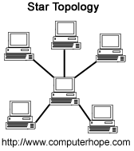Star Topology is a centralised network where all the computers connect to the centre computer. Star Topology is all the nodes have been connected to one individual computer. Therefore, this becomes a shape as a star as that is where it got its name. A star topology is commonly used in homes and offices. This is one of the popular topologies. This type of topology is right for my network, because on the third floor, they are no wired network available. Therefore, for star topology, you can only connect to a central computer to communicate. Unlike bus topology, you will no need of wires to communicate.

Referring to figure 1.1, it demonstrates how the star topology will look like in this company. The central computer is the key as it connects all the computers together to enable communication.

Fig 1.1

**Transmission Control Protocol/Internet Protocol (TCP/IP)**

Transmission Control Protocol and Internet Protocol enables communication by sending information through the router to the targeted area. I believe that this protocol is the right network access because in the scenario, “link the management computers and laptops to the same network so that they can share the internet connection”. In order for this to happen, we need this protocol within the network for the communication to happen. This feature is very important, without TCP/IP, the business could not communicate with each other and share no files. To fulfil the scenario, we need to put this protocol within this company.

Referring to figure 1.2, it demonstrates how the communicate works for any files shared. It goes through all of the layers such as application layer, transport layer, network layer and data link. It has to travel through it and once it reaches the targeted area, it has to travel back to the layers in order for the transportation to be complete.

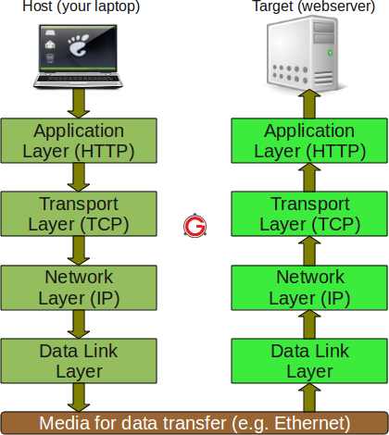

**Types of Protocol**

* **IEEE 802.2**

IEEE 802.2 manages the Ethernet data packets and the upper and lower layers of the model. This means it helps the communication that is transferred between the connections.

* **IEEE 802.3**

IEEE 802.3 helps to detect any data collision when the data is transferred. This is very important for the company, because if the conference staff try to transfer data to the admin staff, this protocol will help if the data is stuck. If too many data is transferred this protocol will help the knot to unknot.

* **IEEE 802.11**

IEEE 802.11 is a protocol aimed that a wireless network. This is very important for the business, because the third floor is going to be using be wireless, “there are no wired networks points in the conference room on floor 3”. This protocol will help the floor transfer data wirelessly.

**Hardware Network Devices**

* **Router**

A router is a device that takes incoming segment of data sent from over two networks. The data transmits through the router. It sends the data from the current location through the router to the destination it supposes to go. It tracks the destined location by using its IP address. Routers can be found in houses and small offices by passing data e.g. email. When the data has been sent, the router tries to find the best possible route to transmit the data. Wireless routers could be slow depending on where the computer is set in the house or small office. A router will be used on the ground and first floor of the company. I cannot use it on the third floor, but the signal will be strong and it will reach to the third floor. I will use a repeater with router on the first floor to make the signal stronger and make it more efficient for it to be in use.

* **Printer**

A printer is used in any organisation to print out documents, pictures and any sort of document that they want to print. This type of network device is very important in any business place. It will not be a simple printer. It will come in all of them: printer, photocopier and scanner. If this printer did not have a photocopier, they would need to leave the organisation to photocopy the document. In addition, they would need it on each floor and all the computers will be connected to the printer. It is important that this company has it on each floor because if they did not, they would need to go all the way to the ground floor to print out, which it time consuming.

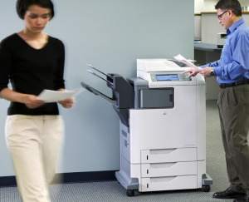

Referring to figure 1.3, I would need this printer on each floor. This allows the user to view the document in a hard-copy format.

**Fig 1.3**

* **Workstation**

A workstation is a desktop computer that is designed for use in an office or business place. It is more powerful and technically designed better than an ordinary personal computer. In the scenario, it states, “the head office requires **5 networked PCs”.** To fulfil this, I would need five PCs. In each floor, admin floor would need three PCs; conference floor would need one PC; and management would need one PC. Workstations are the correct devices for any business as without it, the staff would not be able to complete and share their work with other colleagues.

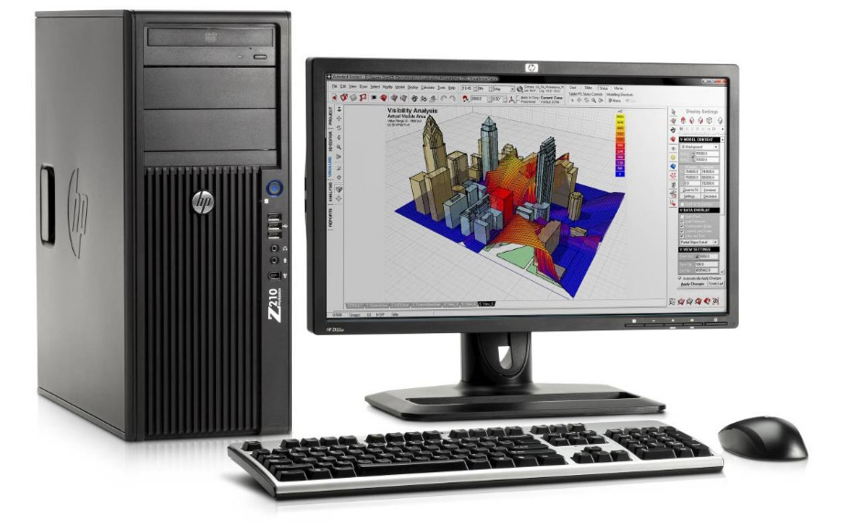

**Fig 1.3**

Workstation is an important hardware and a useful tool. It has the ability that allows the administrator staff to have control over the computer system within the business. Therefore, it can visualise what other staff are doing.

**Software**

**Norton**

An anti-virus is important for any organisation as it helps detect malware and remove them for a subscribed amount of time. Norton needs to be renewed each year. You can purchase them for 3PCs. Therefore, I would need two of them to fulfil five PCs and for them to be protected. The documents need to be protected; therefore, Norton would back-up them for them not be deleted. Norton needs to be scanned regularly for the PCs to stay protected.

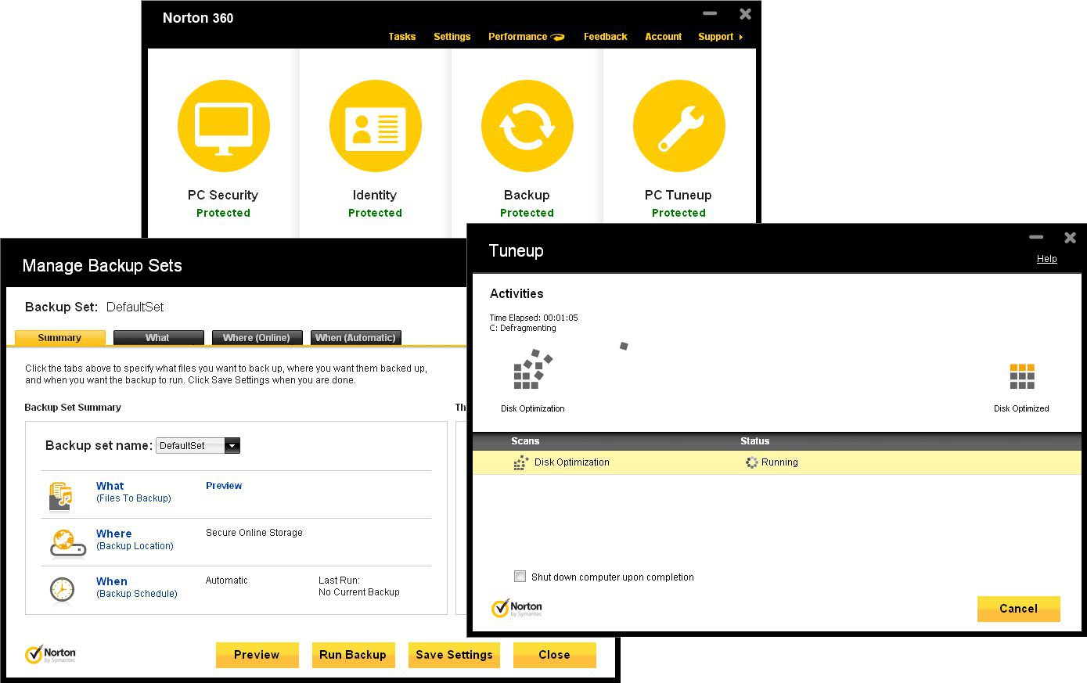

**Fig 1.4**

Referring to figure 1.4, it demonstrates the activities placed inside the software. If shows you if your computer is protected and/or in risk of getting viruses.

**Microsoft Office**

Microsoft Office is important in any organisation. A software allows you to do a number of activities. Microsoft Office has a number of programmes within it e.g:

* Microsoft Word
* Microsoft Powerpoint
* Microsoft Excel
* Microsoft Powerpoint
* Microsoft Outlook

These softwares are commonly used in any organisation. It allows the user to do their work. In addition, you can print the document off if you want a hard copy. I will be placing this document in all of the PCs for the users to “share the document” once they have completed it.



**Types of cabling**

**Dedicated Line**

Dedicated lineis a telecommunication path that enables two points to be able to communicate and send data to each other. It is available for 24 hours and both of the points has to be available and connected to each other for both strands to communicate. A dedicated line can be physical path owned by private users or rented by a company, which then it is called a leased line. I will be using this dedicated line in my business, because it enables communication 24/7. I will be using it on the ground and first floor of the company. I cannot use it on the third floor as “no wired network in the conference room”. Therefore, I will need a mobile phone to communicate. It requires no wired connection and it can communicate 24/7, just like a dedicated line.

**Commercial systems**

**Windows 8**

Windows 8 is the latest version of the Microsoft Windows, as I would like to have all the PCs have the latest version of Windows. It makes it easier to operate for all users such as school, home and office. In order for the organisation to operate, they would need an operating system. Without it, they would not be able to complete their work. The features are very easy to handle and the employees would be able to use it without having training. Windows 8 gives you shortcuts to make it easier for the user to operate the computer. You can personalise your desktop by putting applications, which you use the most. Therefore, all you have to do is click it rather than finding the application and waiting a long time.

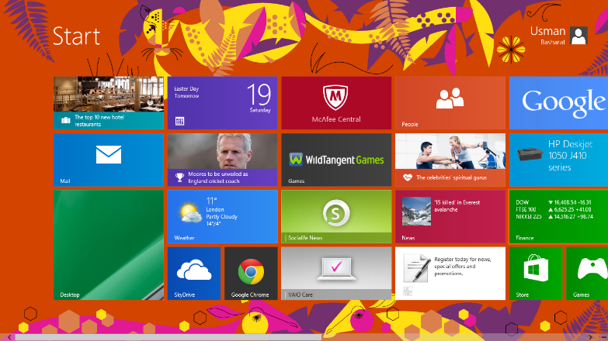

**Figure 1.5**

**Pro’s and Con’s**

***Types of networks***

***LAN***

LANstands for local area network. It says in the name ‘local’. LAN can be used for colleges, schools, universities. The advantages for LAN is that the local area network set up is cheap. In addition, users can transfer data easily. The connection should be relatively fast as they are all connected to the same network. If one workstation crashes or the network does not work, others will not be effected. On the other hand, the disadvantage for LAN is in every problem for network. The security for network is a real problem. Once a person finds out the password that is set for the network, they could get access with all the information that is shared. If the password is successful, it could do a lot of damage to the whole network system. Both workstations need to be switched on in order to transfer data.

***Topology***

***Star***

Star Topology is all the nodes have been connected to one individual computer. Therefore, this becomes a shape as a star as that is where it got its name. A star topology is commonly used in homes and offices. This is one of the popular topologies. The advantage of using star topology is that it is installed quickly. As it is connected to a central hub, the performance does not affect other computers because it is not connected to them. Therefore, replacing any nodes is very easy, as you are not disturbing any other computers. In addition, if any problems occur, the central hub will pick it up and it will be traced easily of which node is the problem. On the other hand, if the central hub’s servers were slow, it would affect the performance of the other computers. It takes many cables to set up the network..

**Network access methods**

***TCP/IP***

TCP/IP is the transportation of data. The advantages for using TCP/IP is that it gets to its targeted area when it needs to. It does not duplicate, it will arrive at its destination. Another advantage is that communication is better within a network. Because it has traced/knows the IP address, all the TCP/IP have to do, is deliver the data to the computer. Therefore, it is easier to use this in the business. However, the disadvantage is that is has many features of that may not be needed. It wastes a lot of time complete these mini-tasks rather than using it when it another task can be done. Lastly, another disadvantage is that the rate is low. For example, if the user wants to download the arrived file, it will take very long for it to download. It takes time depending on how long the file is.

***Network devices***

***Printer***

All-in-one printer (print, copy and scan) in your business saves a lot money. This is because the business does not have to spend an additional amount of money for a printer and a copier. It comes all in the printer. In addition, printers can be shared within a network e.g. connects all the computers in the room together so they can print in that printer. However, the biggest disadvantage that can cost a lot to the business is the ink and printing paper. Once the ink and printing paper has ran out, you need to replace it quickly in order for it to print again. Black and colour ink costs a lot of money. Using a lot of printing paper, it could damage the environment. For example, paper comes from trees. The more you use paper; you would kill all the trees. However, once you have the ink and printing paper, it will take a long time for it to run out e.g. maybe one/two month. In addition, having all-in-one printer takes a lot of space. You need space on the floor to fit.

***Router***

Having a router in your business solves many security problems you may have. Modern routers have improved tremendously. They have a built in firewall. This prevents any other network trying to get access to your network. In addition, routers come wirelessly. You can place the wireless router anywhere on the floor and the computer scan still have access to the internet. However, having a wireless router, it can have a slow connection. The signal strength may not be as best so it is best you stay close to the router as much as possible to get a good, strong connection. Depending on which router you get, the costs varies. The best routers normally cots more.

***Workstation***

Having workstations in your company is important. The biggest advantage of using a workstation is that it is easier and quicker for the staff to store information. If did not have a computer, you would have to do all your work on a piece of paper. Therefore, there is more risk of storing it on paper and losing the paper than it is on a computer. However, having a computer does not come cheap, on average it costs around £600, depending on which workstation you get. In addition, spending a lot of time on the computer could damage your eyesight and the way you sit on the computer. The user has to sit in a good position to prevent any health and safety risks. The user has to have a comfortable chair for it to prevent any damage to the computer.

***Software***

***Norton***

Having Norton on your computer is important. You can use Norton on any commercial system e.g. Windows, MACs, Linux. It varies on any operating system. Each year, Norton release a better and upgraded version of the previous Norton for it to become better with new features. However, the disadvantage of using Norton is that the user has to renew the Norton each year. This costs the business each year for the computers to stay protected. In addition, the highest number of times you can download Norton is 3PCs. We have 5PCs. Therefore, we need to get two versions of Norton in order to fulfil the requirement.

***Microsoft Office***

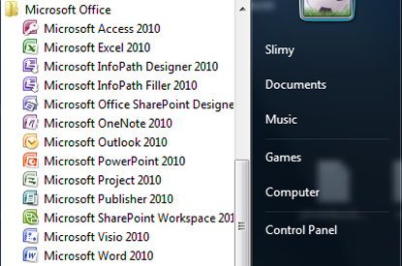The advantages of using Microsoft Office is that it comes with different programmes. They are many and you can use Microsoft Office on any platform. As you can see, they are loads of them. In addition, they update to release new features. However, the only disadvantage for using Microsoft is the cost. It costs around £100 and it ranges depending on how many PCs you want to download it.

***Commercial systems***

**Windows 8**

The advantage of using Windows 8 is that it when you buy a laptop, you will need to check if Windows 8 is built into the device. It is easy to use for a user that is used to using computers. However, it may be difficult for users if they are new. Compared to Windows 7, it is very different e.g. the start screen.

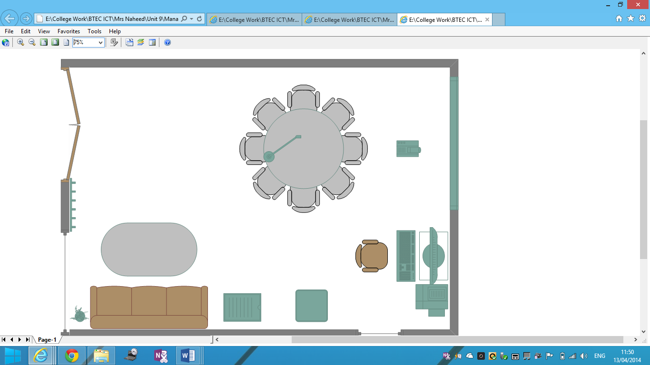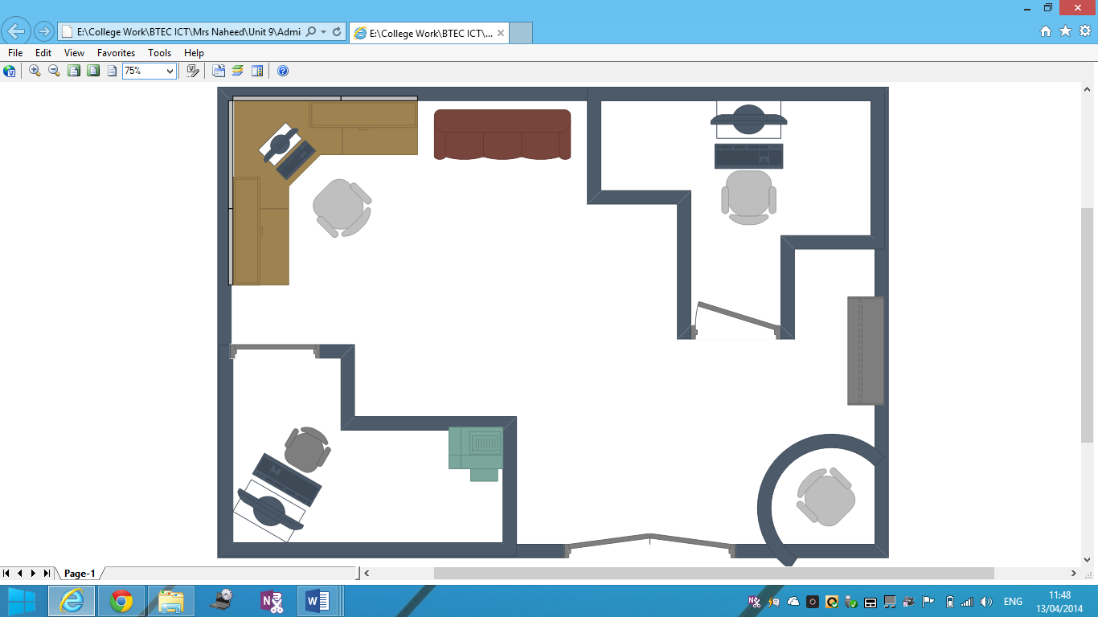**M2**

Conference

Admin

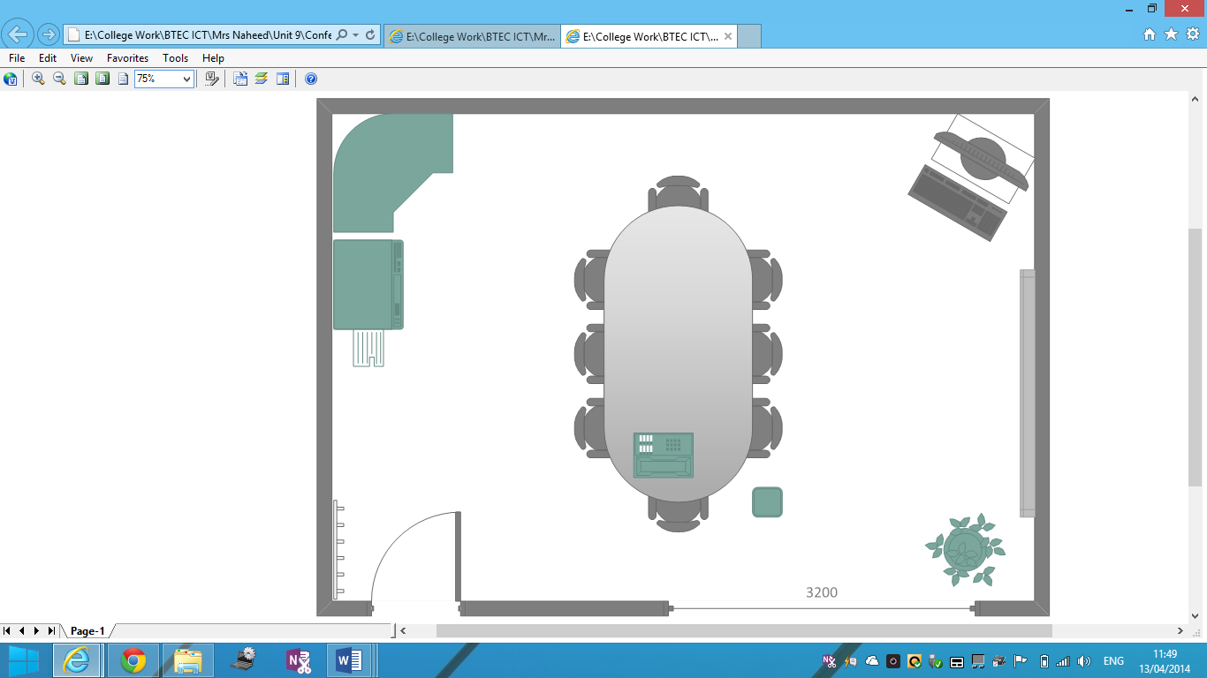

Management

***Conclusion***

The potential difficulties that I have faced is many issues that I have to dealt once I was designing the floor plan was that I would need enough space for each employee. I needed some space as for conference, they are held meetings, and therefore I would need a table for the floor to deal with the meetings. I would need lifts for disabled people that enter the company. It is a requirements for every organisation and a loft would be suitable for it. It could be a held near the stairs. They can be many problems when we deal with the software we download e.g. printing problem. To prevent this from happening, we can hire an employee and each day his duty is to check every day each software and hardware if it’s working. If they is a major problem, I would need to refer to another company to get it checked out if it’s a major problem. Meanwhile, I would have a spare laptop that the employee can use in order to complete his work. This could prevent many problems and it could not cost anything to the business. A printing problem could be an issue e.g. if it runs out, where would we go. The information could be one of many problems that any organisation would face. In order to prevent any data loss, each employee would have a USB contained with them. Each week, they would need to save their work on the USB. It is important they need to save it otherwise, if they do not, they would lose it and it could cost them a lot of time to get it back. To prevent this from happening, I would need to stack loads of printing paper and make sure it is used. To summaries, I have learnt many lessons in this task in order to prepare me for the future.

***Reference***

***P1***

***P3***

***P4***

[**http://www.computerhope.com/jargon/s/star.gif**](http://www.computerhope.com/jargon/s/star.gif) **Fig 1.1**

[**http://static.thegeekstuff.com/wp-content/uploads/2011/10/tcp-ip.png**](http://static.thegeekstuff.com/wp-content/uploads/2011/10/tcp-ip.png) **Fig 1.2**

[**http://regmedia.co.uk/2011/04/11/z210_cmt_large.jpg**](http://regmedia.co.uk/2011/04/11/z210_cmt_large.jpg) **Fig 1.3**

[**http://cdn1.pcadvisor.co.uk/cmsdata/reviews/3340449/Symantec_Norton_360_v6.jpg**](http://cdn1.pcadvisor.co.uk/cmsdata/reviews/3340449/Symantec_Norton_360_v6.jpg) **Fig 1.4**